H.T No
Regulations:
A15


Sreenidhi Institute of Science and Technology
(An Autonomous Institution)
Code No: 5CC04 Date: 15-June-2019 (AN)

B.Tech II Year I-Semester External Examination, June-2019 (Supplementary)
Signals and Systems (ECE)

Time: 3 Hours Max.Marks:75

Note: a) No additional answer sheets will be provided.
b) All sub-parts of a question must be answered at one place only, otherwise it will not be valued.
c) Missing data can be assumed suitably.

Part - A Max.Marks:25

Answer all QUESTIONS.

1. | Determine the relation between impulse and step signals. | [3M]
2. | Define Hilbert transform. How does it differs from other transforms? | [3M]
3. | Define linear system. | [3M]
4. | Give the significance of power spectral density. | [3M]
5. | What is aliasing? How to eliminate aliasing effect? | [3M]
6. | Explain the significance of unit circle in Z-transform. | [2M]
7. | Find the Fourier transform of the unit step function. | [2M]
8. | State Paley-Wiener criterion. | [2M]
9. | Write the properties of cross correlation. | [2M]
10. | What is meant by region of convergence (ROC)? | [2M]
Part – B Max.Marks:50
ANSWER ANY FIVE QUESTIONS. EACH QUESTION CARRIES 10 MARKS.

11. | a) | Sketch the following signals  i. 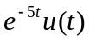 ii. 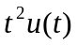 iii. 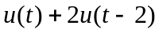 iv. 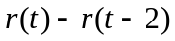 v. 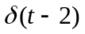 | [5M]
 | b) | Prove that complex exponential functions are orthogonal functions. | [5M]
12. | a) | Find the Fourier series for the periodic signal 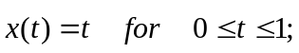 so that it repeats every 1 second. | [5M]
 | b) | Find the Fourier transform of the signum function and plot its amplitude and phase spectra. | [5M]
13. | a) | Derive the condition for distortion less transmission through a system | [5M]
 | b) | Explain the characteristics of an ideal LPF. Why ideal filters are physically not realizable? | [5M]
14. | a) | Obtain the cross correlation of the signals x₁(t) = Sin(4πt), x₂(t) = Cos(4πt). | [5M]
 | b) | Find the Laplace transform and ROC of the signal 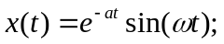. | [5M]
15. | a) | State and prove sampling theorem for band limited signals using graphical approach. | [5M]
 | b) | Compare various sampling methods. | [5M]
16. | a) | State and prove initial and final value theorems of Z-transform. | [5M]
 | b) | Find the Inverse Z-transform of the following:  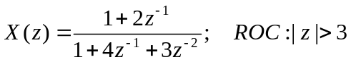 | [5M]
17. | a) | Discuss complex Fourier spectrum of periodic functions. | [5M]
 | b) | Explain causality and physical realizability of a system and hence give Paley-Wiener criterion. | [5M]
18. | a) | State and prove the relation between convolution and correlation. | [5M]
 | b) | Distinguish between Fourier, Laplace and Z transforms. | [5M]
-- 00 -- 00 –

